2. REGISTER TRANSFER AND MICROOPERATIONS

- Design and explain the combinational circuit for four-bit arithmetic circuit.
- Arithmetic circuits can perform seven different arithmetic operations using a single composite circuit.
- It uses a full adder (FA) to perform these operations.
- A multiplexer (MUX) is used to provide different inputs to the circuit in order to obtain different arithmetic operations as outputs.

4-bit Arithmetic Circuit :
Consider the following 4-bit Arithmetic circuit with inputs A and B. I
t can perform seven different arithmetic operations by varying the inputs of the multiplexer and the carry.
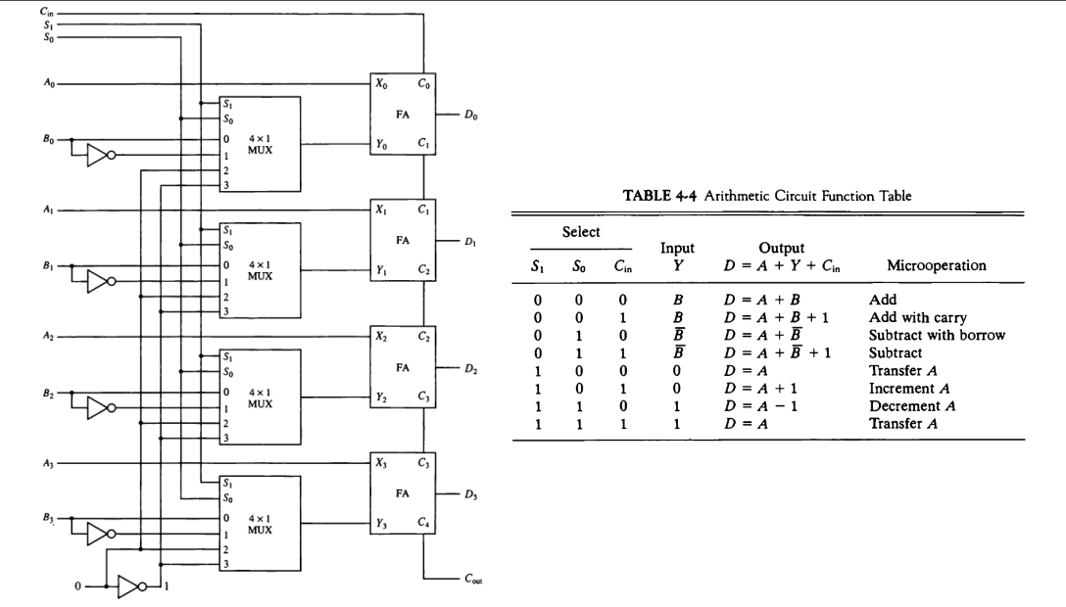

- What is use of control function in Register Transfer language?
If the control function P=1, then load the content of R1 into R2 and at the same clock load the content of R2 into R1.

- Draw Common Bus System diagram of 4-bit, 4 Registers. Explain the function of Selection lines to transfer data from Registers to Common Bus.
A Common Bus System is a scheme for transferring information between registers in a multiple-register configuration
A bus: set of common lines, one for each bit of a register, through which binary information is transferred one at a time Control signals determine which register is selected by the bus during each particular register transfer
The following block diagram shows a Bus system for four registers.
It is constructed with the help of four 4 * 1 Multiplexers each having four data inputs.
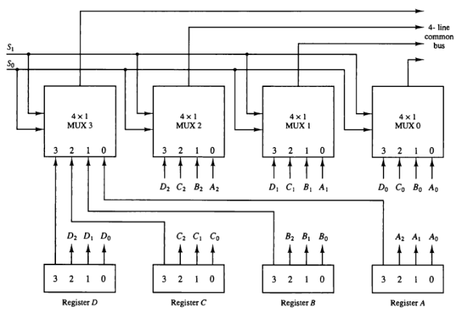
The bus consists of 4×1 multiplexers with 4 inputs and 1 output and 4 registers with bits numbered 0 to 3.
There are 2 select inputs S0 and S1 which are connected to the select inputs of the multiplexers.
The data transferred to the bus depends upon the select lines.
A table for the various combinations of select lines is shown below.
Select Lines combination S1S0 | Register Selected
00 | Register A
01 | Register B
10 | Register C
11 | Register D
As we can see that when S1S0=00, register A is selected because on 00 the 0 data inputs of all the multiplexers are applied to the common bus.

Since the 0 data inputs of all the multiplexers receive the inputs from the register A, thus register A gets selected.
Similarly for other combinations of S1S0 other register are selected.
4. Design Circuit for logic Micro Operations.
The hardware implementation of logic microoperations requires that logic gates be inserted for each bit or pair of bits in the registers to perform the required logic function
Most computers use only four (AND, OR, XOR, and NOT) from which all others can be derived.
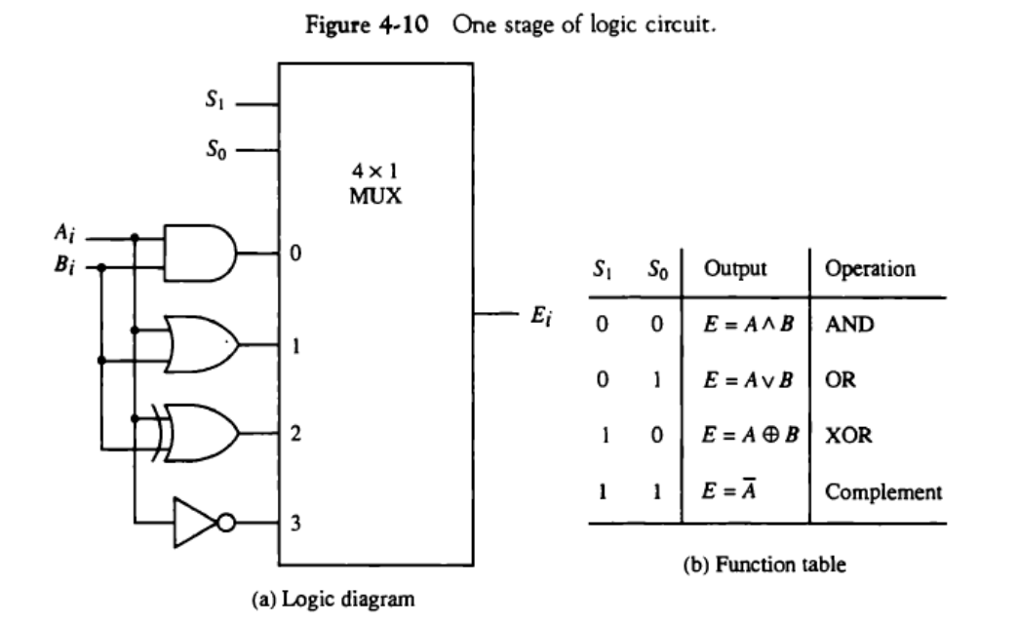
- What is register transfer language?
a symbolic notation to describe the microoperation transfers among registers
Information transfer from one register to another is described by a replacement operator: R2 ← R1
This statement denotes a transfer of the content of register R1 into register R2
The transfer happens in one clock cycle The content of the R1 (source) does not change The content of the R2 (destination) will be lost and replaced by the new data transferred from R1

- What are the three states of Three-State Buffers?
has three possible output states:
HIGH (1),
LOW (0)
floating (Z).
The tristate buffer has an input A, output Y, and enable E.
When the enable is TRUE, the tristate buffer acts as a simple buffer, transferring the input value to the output.
- List and explain Shift micro-operations.
used for serial transfer of information
Also used in conjunction with arithmetic, logic, and other dataprocessing operations

Three types of shift:
Logical,
Circular
Arithmetic
1. Logical :
It transfers the 0 zero through the serial input.
We use the symbols shl for logical shift-left and shr for shift-right.

Logical Shift Left –
In this shift one position moves each bit to the left one by one.
The Empty least significant bit (LSB) is filled with zero and the most significant bit (MSB) is rejected.

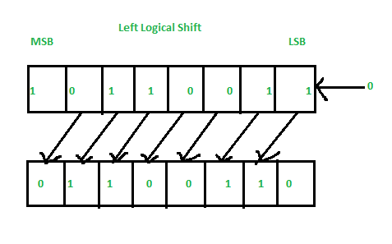
Right Logical Shift –
In this one position moves each bit to the right one by one and the least significant bit(LSB) is rejected and the empty MSB is filled with zero.

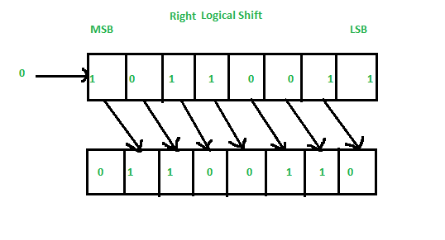

2. Arithmetic :
This micro-operation shifts a signed binary number to the left or to the right position. In an arithmetic shift-left, it multiplies a signed binary number by 2 and In an arithmetic shift-right, it divides the number by 2.

Left Arithmetic Shift –
In this one position moves each bit to the left one by one. The empty least significant bit (LSB) is filled with zero and the most significant bit (MSB) is rejected. Same as the Left Logical Shift.

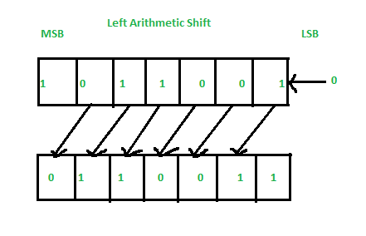

Right Arithmetic Shift –
In this one position moves each bit to the right one by one and the least significant bit is rejected and the empty MSB is filled with the value of the previous MSB.
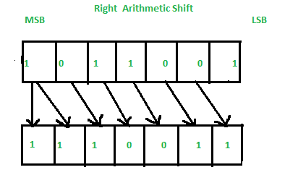

3. Circular :
The circular shift circulates the bits in the sequence of the register around the both ends without any loss of information.

Left Circular Shift –
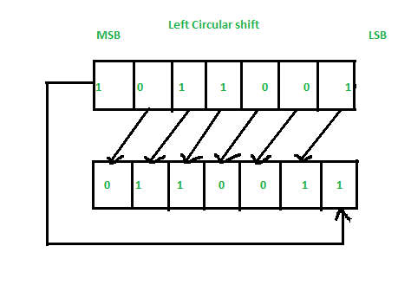

Right Circular Shift –

